Each figure in a sequence is made in the shape of star, the first three instances of this sequence are shown below.

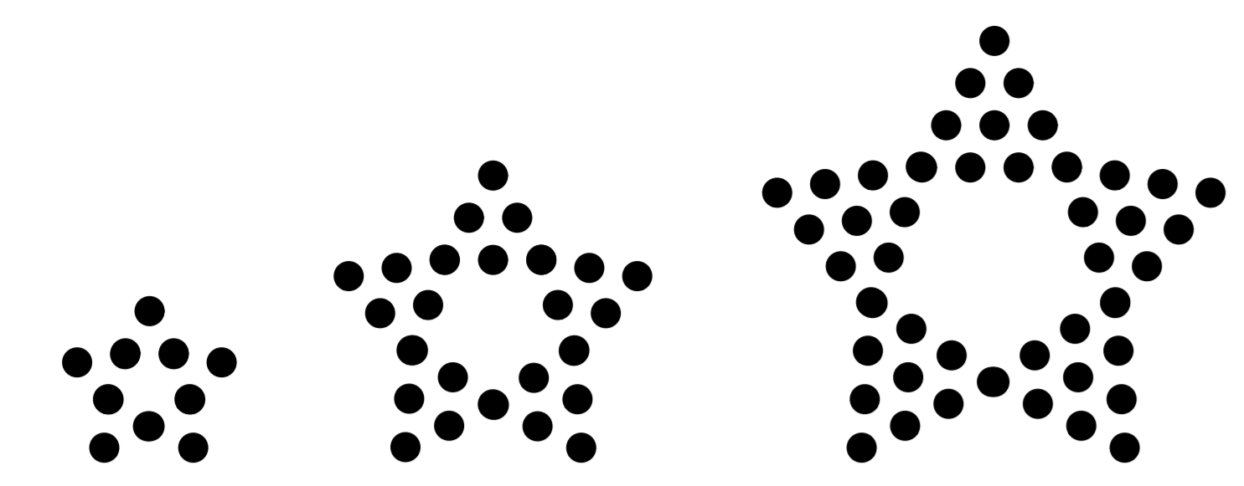

Each star figure is composed of five triangle figures placed such that two vertices of each triangle is connected to a vertex of another triangle. Because of this we can model the number of dots in each star as $s\left(x\right)=t_{x}⋅5-5$. To determine the number of dots in each triangle figure, we can solve it using second order polynomial, $t(x)=\frac{1}{2}x^{2}+1\frac{1}{2}x+1$.

This formula can be determined using the following substitutions.

$$3=a+b+c , 6=2a+2b+2c$$

$$6=4a+2b+c,0=-2a+c,c=2a$$

$$3=3a+b,9=9a+3b$$

$$9=9a+3b, 10=9a+3b+c, 1=c$$

$$c=2a, 1=2a, \frac{1}{2}=a$$

$$3=\frac{1}{2}+b+1, 1\frac{1}{2}=b$$

$$y=\frac{1}{2}x^{2}+1\frac{1}{2}x+1$$

Combining these two functions we can determine that $s(x)=2\frac{1}{2}x^{2}+7\frac{1}{2}x+5-5$, or further simplified $s(x)=2\frac{1}{2}x^{2}+7\frac{1}{2}x$. To determine a figure such that the number of dots in 20,020 we can use $20,020=2\frac{1}{2}x^{2}+7\frac{1}{2}x$, which when simplified reveals the roots of this equation to be -91 and 88, however we know when the figure increases the dots strictly increase, therefore figure number 88 contains 20,020 dots.